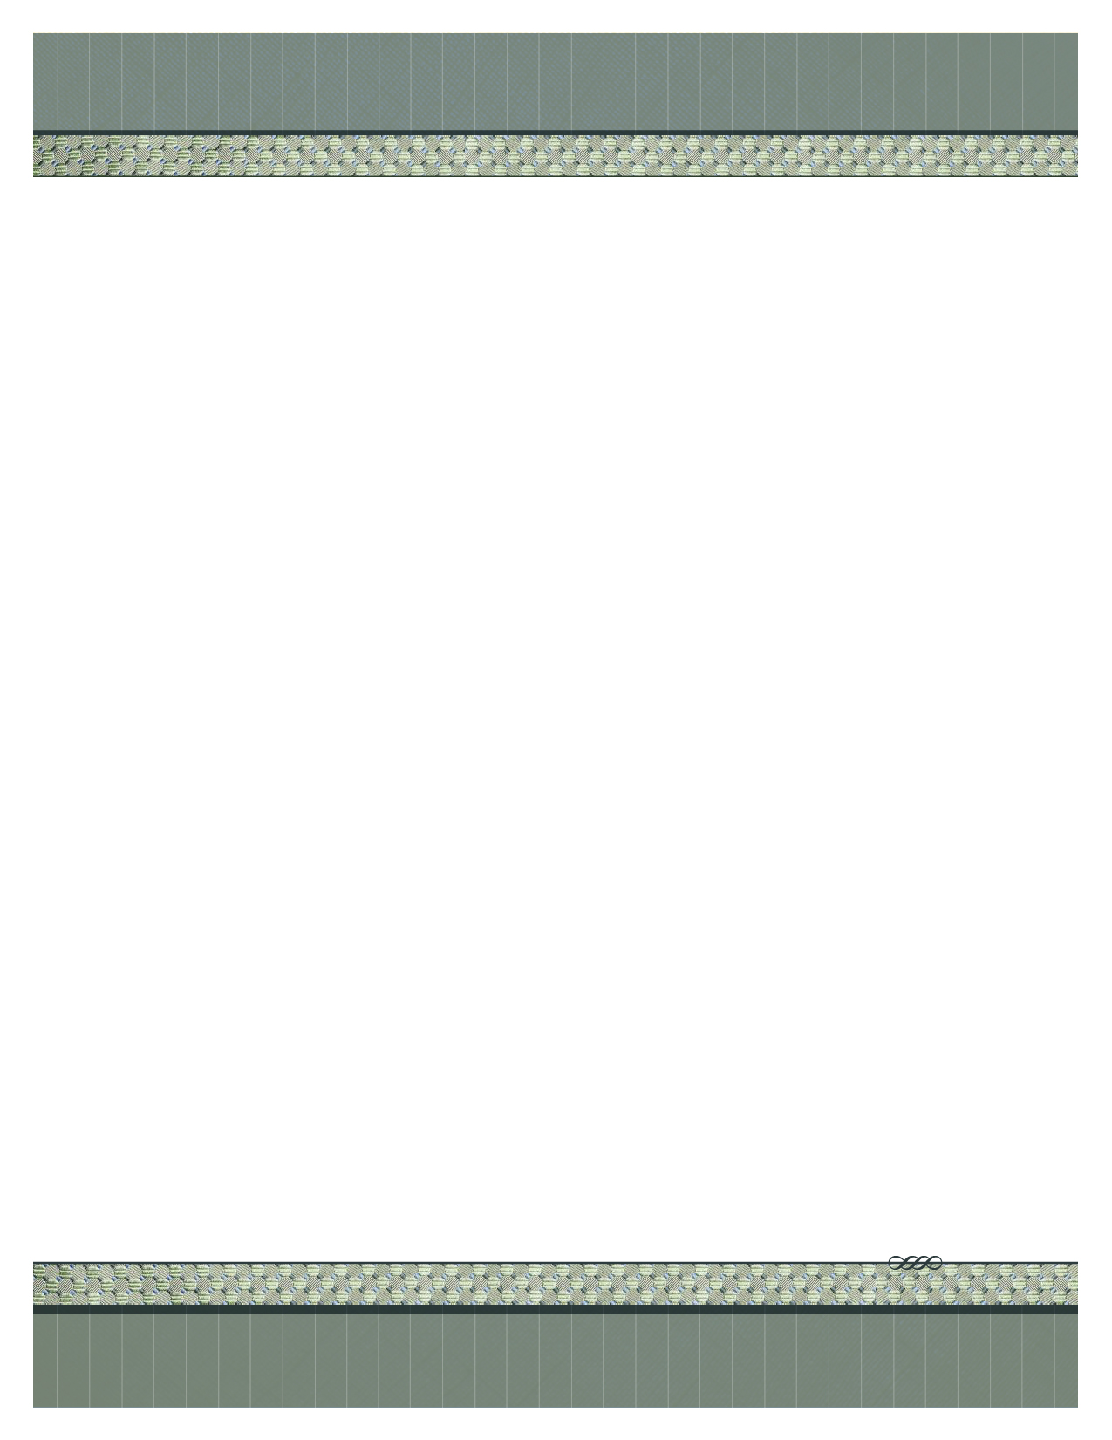



www.facebook.com/MAPGRAPHICS

[www.mapgraphicsphotos.smugmug.com](http://www.mapgraphicsphotos.smugmug.com)

Phone: 518-376-4621

M.A.P. Graphics

“ Cabaret Night 2014” CD Get of over 100

“ High Resolution “ Photos of the Students performing their Talents A Great “ One of a Kind “ Holiday Gift . If you would like to preview the photos, feel free to go to :

[www.mapgraphicsphotos.smugmug.com/2014-Cabaret-Night](http://www.mapgraphicsphotos.smugmug.com/2014-Cabaret-Night)

If there are specific photos you would like to order prints of, use the Discount Code : ***CabaretNight*** (one word) at check out and receive 30% off your print or merchandise order online. ( this does not apply to CD orders )

Payment received $ __________ # Cd’s _____

# of cd’s _____ Total $ __________

Name: _________________________

Address: ________________________

________________________

________________________

**Performance School of Arts Photo CD**

**$20.00 $15.00 (School Price)**

Make all checks payable to **M.A.P. Graphics**

**THANK YOU FOR YOUR BUSINESS!**